Annual Report 2019
Sambhav Social Service Organisation
www.sambhavindia.org

Contents
Sambhav Social Service Organisation: 4
Goal: 4
Mission Statement: 4
Vision: 4
Aims and Objectives 4
Governance 4
Area of Operations 5
Operating Model: 5
Approaches of Sambhav: 5
Team Sambhav 6
Organogram 7
Jai Jagat 2020 8
ReNew India Initiative 10
Parivartan 15
Community Needs Assessment: 19
E- Community- Educated, Empowered, Enabled, Expressive 21
Sabla- Program on Violence Against Women 25
Self Help Promotion 27
Shri Padam Sambhav Eye Hospital 27
Radio Dhadkan: Bridging the Digital Divide 28
BALANCE SHEET AS AT 31ST MARCH 2019 32

Freedom Xiv - Khalil Gibran
And an orator said, "Speak to us of Freedom." And he answered:

At the city gate and by your fireside I have seen you prostrate yourself and worship your own freedom, Even as slaves humble themselves before a tyrant and praise him though he slays them.
Ay, in the grove of the temple and in the shadow of the citadel I have seen the freest among you wear their freedom as a yoke and a handcuff. And my heart bled within me; for you can only be free when even the desire of seeking freedom becomes a harness to you, and when you cease to speak of freedom as a goal and a fulfillment.
You shall be free indeed when your days are not without a care nor your nights without a want and a grief, But rather when these things girdle your life and yet you rise above them naked and unbound. And how shall you rise beyond your days and nights unless you break the chains which you at the dawn of your understanding have fastened around your noon hour?
In truth that which you call freedom is the strongest of these chains, though its links glitter in the sun and dazzle the eyes. And what is it but fragments of your own self you would discard that you may become free?
If it is an unjust law you would abolish, that law was written with your own hand upon your own forehead.
You cannot erase it by burning your law books nor by washing the foreheads of your judges, though you pour the sea upon them. And if it is a despot you would dethrone, see first that his throne erected within you is destroyed.
For how can a tyrant rule the free and the proud, but for a tyranny in their own freedom and a shame in their won pride? And if it is a care you would cast off, that care has been chosen by you rather than imposed upon you.
And if it is a fear you would dispel, the seat of that fear is in your heart and not in the hand of the feared. Verily all things move within your being in constant half embrace, the desired and the dreaded, the repugnant and the cherished, the pursued and that which you would escape.
These things move within you as lights and shadows in pairs that cling. And when the shadow fades and is no more, the light that lingers becomes a shadow to another light.
And thus your freedom when it loses its fetters becomes itself the fetter of a greater freedom.

A Message

As we begin this New Year of 2020, we want to fill our hearts with hope for things anew. Today we stand at a historical juncture “two paths that divide in a yellow wood” where greater violence in our families and society could become the norm, or where we could choose the path of peace. At least in the next year, we can make choices. It is no disputing that most people will line up on the side of peace but the problem is that that is not always reflected in our actions. We need to think everyday peace so, how to bring nonviolence into our daily lives – how our actions play out in Realtime. We take decisions in our homes, and although we think ethical people sometimes can carry out some small unethical acts, we need to think twice about the implications of our action. Are we feeding a cycle of corruption? Are we hurting others? What implication does this have on other people if I have to constantly lie to cover up just one small mistake. At a larger level, we are all devise listening to the call of commerce which oftentimes unethical. Can we be conscientious in these judgements?

As I am writing this from the Jai Jagat global peace march, having now crossed 1400 kilometres on the 11,000 kilometer walk to Geneva, we are seeing how people are unknowingly keeping the Sahariya Adivasis group poor for the sake of power and profit. Many communities in our walk-through Shivpuri, Sheopur, Ashok Nagar made us remember that people are not thinking about this community as they take judgements whether as consumers, policy makers, bureaucrats, NGOs or the general public. The way they live is sheer depravity and they are some of the most nonviolent people on the planet. So, is the idea to spread peace by first removing the nature dependent communities who have found an accommodation with nature and with eac h other…? We need to ponder as we go into the next year.

I want to commend Sambhav for their years of work with Sahariya’s, they stand out as a stirling example of four decades of work with Sahariya’s. We wish them well in their future work, because this is genuine peacebuilding.

Jill Carr-Harris, PHDc
Gandhian Trainer
International Coordinator, Jai Jagat 2020

Sambhav Social Service Organisation:
Sambhav is a voluntary organization engaged on the issues of women empowerment, violence against women, education and health. The organization also works in the direction of capacity building of communities for community organization especially of Sahariya Tribal Group and Urban Slum Dwellers.

Goal: “Equality, Opportunity and Justice for All”
Mission Statement: "Building equitable, democratic and environmentally sustainable society."
Vision: "Striving for sustainable development processes and improvement in the quality of life of vulnerable people like Tribal, women and children through their organization and capacity building efforts.”

Aims and Objectives
- To initiate the awakening process
- To build up the people’s organization
- To build the capacities of the people
- To work with the poor and oppressed and not for them
- To encourage development of a democratic process towards people’s solidarity
- To strengthen women in the expression of their full potential and rightful place in the society
- To try integrated and sustainable models of community health and rural development using, people’s participatory approaches.
- To strengthen community voices through advocacy efforts.

The organization is led by a Governing Board, which has the secretary nominated on its behalf to oversee the day to day operations of the program. Sambhav follows a program based approach to its intervention, where programs are headed by their respective coordinators, followed by field level staff. The next level of the support group of the organizations is the community-based organizations such as women collectives, SHGs , adolescent groups, and like-minded individuals that facilitate the operations of the organization at the ground level.

Governance

S.No. | Name | Designation | Profession
1 | Smt. Khairo Bai | President | Women Activist
2 | Dr. Avinash Tiwari | Vice-President | Academician
3 | Dr. Shiv Kumar Singh | Secretary | Social Worker
4 | Ms.Neelam Kulshreshtha | Treasurer | Entrepreneur
5 | Dr. Rahul Singh Bhadauria | Joint Secretary | Doctor
6 | Ms. Mamta Singh Bais | Member | Academician
7 | Ms. Neha Singh | Member | Academician

Area of Operations
Sambhav primarily works in the Chambal, Bundelkhand and Malwa Region of Madhya Pradesh in the districts of Gwalior, Bhind, Sheopur, Shivpuri, Chhatarpur and Dhar

S.No. | District | Program Name | Thematic Focus
1 | Gwalior | Self Help Promotion Institute | Financial Inclusion
 |  | Sabla | Violence Against Women
 |  | Mukhya Mantri Kaushal Samvardharn Yojna | Livelihood
2 | Bhind | Parivartan | Education, Health, Women Empowerment, Infrastructure Improvement
3 | Sheopur | ReNew India Initiative | Education, Health, Women Empowerment, Infrastructure Improvement
4 | Dhar | E-Community | Health, Education, Women Empowerment
5 | Shivpuri | Radio Dhadkan | Community Radio
 |  | Shri Padam Sambhav Eye Hospital | Eye care
6 | Bhopal/Dhar | Community Needs Assessment | Research
7 | Chhatarpur | Swachch Bharat Abhiyaan  Eye Camps | Sanitation and Health  Eye Care
8 | International | Jai Jagat 2020 | Campaign

Operating Model:
Sambhav believes in working with the people and not for them. As a result of the same thought process, all the programs are designed and implemented with maximum ownership and participation of the community. The community-based groups and support groups identified from within the community play a critical role in deciding upon the modus-operandi of the program. This is also critical from the sustainability point of view. Once the organization is not able to continue the program in an area, the entire process should not collapse, hence the community needs to be in the center of program implementation.

Approaches of Sambhav:
-Women Empowerment through community based group formation, which includes micro-saving at internal level through Self Help Groups and Financial Inclusion.
-Working in close convergence with the government machinery to make ground level interventions and introductions sustainable and participatory.
-To work with the people and not for them.

Sambhav is a grassroots-based organization with its interventions around the most socio-economically marginalized communities. At one end where the organization is working with PVPTG Sahariya Tribe, it is also working with women from urban slums. Sambhav draws its strength believing that the community and women are the real leaders of a program. Sambhav as an organization can only play the role of a facilitator, but the processes need to be owned and taken ahead by the community itself.

In terms of organizational capacity, 32 years of existence and intense work on the issues related to women and vulnerable, has helped the organization build in house expertise in terms of training resource persons, community organizers, behavior change communication and so on. This has substantially contributed to lesser dependence of the organization on the third party.

Working relations with local administration and understanding of the way the government machinery works gives a heads-up to the organization in planning and implementing a more realistic and doable program.

Team Sambhav
S.No. | Name | Position
1 | Priyanka Singh | Head of Operations
2 | Gaffar Khan | Admin Officer
3 | Hanim Khan | Coordinator- SHPI
4 | Nabil Singh | Head-Programs
5 | Vivek Sharma | Community Mobilizer
6 | Sirnaam Singh | Community Mobilizer
7 | Deepak Kushwah | Computer Educator
8 | Gopal Gupta | Office Assistant
9 | Pragati Mishra | Program Coordinator
10 | Badam Singh | Community Mobilizer
11 | Sangeeta Bhadoria | Community Mobilizer
12 | Arun Deep | Remedial Educator
13 | Ram Avtar | Remedial Educator
14 | Poonam Rathore | Remedial Educator
15 | Arvind Shakya | Remedial Educator
16 | Ankita Shrivastava | Project Coordinator
17 | Mithilesh Pathak | Accounts Officer
18 | Bhanwar Singh | Driver
19 | Himanshu Yadav | Community Mobilizer
20 | Pooja Dangi | Supervisor
21 | Mala Sharma | Women Mobilizer
22 | Deep Shikha | Community Mobilizer
23 | Jaishree Sejgaya | Remedial Educator
24 | Shalini Kalbhor | Remedial Educator
25 | Pooja Kalbhor | Remedial Educator
26 | Anju Thakur | Remedial Educator
27 | Ayushi Mishra | Remedial Educator
28 | Kavita | Remedial Educator
28 | Satoshi Sen | Remedial Educator
29 | Dr. Durgesh Prasad | Medical Officer
30 | Deepika | Staff Nurse
31 | Krishna | Computer Teacher
32 | Kishore Sejgaya | Community Mobilizer
33 | Priya | Remedial Educator
34 | Ramsevak Sen | Community Reporter
35 | Champa Bai | Community Reporter
35 | Ramvati Bai | Community Reporter
36 | Laxmi Goyal | Community Reporter
37 | Lachchi Ram | Health Volunteer
38 | Kalyan Singh | Health Volunteer
39 | Shankari Biswas | Peon
40 | Pooja | Peon
41 | Neha Singh | Consultant- Education
42 | Mamta Singh | Consultant- Education
43 | Dr. Akhilesh Tomar | Consultant- Health
44 | Dr. Anjali Kushwah | Consultant- Health
45 | Sandip Naik | Consultant- Community Development
46 | Naveen Gupta | Chartered Accountant
47 | Vivek Gupta | Consultant- Legal
48 | Adv. Gurudatt Sharma | Consultant- Legal
49 | Adv. Kamal Kishore | Consultant- Legal
50 | Adv. Purnima Nigam | Consultant- Legal
51 | Ramgopal Sharma | Coordinator
52 | Kamlesh Upadhyay | Supervisor

Organogram
Governing Board
Community
Finance Officer
Field Staff
Project Coordinator
Operations
Programs
Purchase Committee
Advisory Board
Secretary

Jai Jagat 2020
We have the age-old problem of unfairness, injustice, poverty, and marginalization of poor communities, and now, the devastating threat of climate change also must be addressed. Our finest traits and ideas will need to be harnessed to improve the lives of individuals, communities, and countries and, ultimately, the whole planet, as we work together for our common wellbeing.

The Jai Jagat vision emerged as Rajagopal, Eminent Gandhian and founder member of Sambhav, visited numerous groups and projects throughout India and other nations to explain nonviolent methods of empowering poor communities. Seeing how individual groups were having an impact on their own communities, the clear next step was to link them together to create a movement that could provide effective solutions to the problems we face.

Never in human history have we faced such a crisis as we face now. There are the ancient problems of poverty and injustice, along with new and escalating wars and migration on a massive scale. Increasing automation is bringing the mass employment model of capitalism to an end. Millions of jobs are threatened as human labor becomes redundant across many industries. In addition to all that, the profound effects of global warming and extreme weather conditions need to be halted, or at least mitigated, to prevent a catastrophic future with significantly diminished food and water.

There is a need, right now, for a coherent global movement to make its presence felt and press for international peace and co-operation. Our time left to work together to save the planet is fast running out. Reducing conflict, excessive and unsustainable consumption, the increasing gap between rich and poor, greenhouse gases and injustice on a global scale is all an epic challenge that might seem insurmountable, but this is how it is and we have to start somewhere.

For the British Empire to give up India, its colonial jewel, without bloodshed, would have seemed nothing more than an impossible dream when Mahatma Gandhi first joined in the struggle for India’s independence, yet he lived to see his dream happen. Gandhi’s mantras of non-violence and individual improvement in the interests of the collective good are the cornerstone of the Jai Jagat manifesto. His idea of Sarvodaya (“progress for all”) envisaged encouraging people to overcome the great challenges in their lives through collective action.

The Jai Jagat manifesto suggests what collectively we might effectively do to prevent a disastrous future. The Green and White booklet has as its aim that we have the new mass movement that we need and that we work together for the same common goals. The Green alludes to our recovering a balanced relationship with our planet and the White to the struggle for peace based always on justice. We hope the vision we have shared in the booklet will inspire the will and courage in millions to improve their lives individually and collectively.

What Gandhi said all so many years ago still stands: ‘The means may be likened to a seed, the end to a tree, and there is just the same inviolable connection between the means and the end as there is between the seed and the tree.”

Nonviolence is a way of life because we have to engage in a continual struggle to overcome our inner violence. Gandhi’s use of Satyagraha (translated as ‘truth-force’) was to find an inner power to overcome obstacles and bring about external change. Six commitments have been identified that can help everyone harness their inner power.

- A commitment to personal change
- A commitment to protect the life-nurturing systems of the earth
- A commitment to nonviolent social action
- A commitment to nonviolence as a way of life
- A commitment to global citizenship
- A commitment to justice, human rights, and democracy

This vision is intended to give people, particularly young people, a sense of their individual and collective strength, and a realization of the power they can, individually and collectively, wield rather than wait for governments and international bodies to come to a decision to act in positive, beneficial ways.

We are all beginning to grasp the possible catastrophic consequences of a rise of even 1.5°C, let alone 2°C, in our average global temperature. Human ingenuity on a local level can lead to global change. Jai Jagat is striving to link bottom-up, grassroots innovations and schemes across the world to combat climate change.

Jai Jagat advocates reforming education to ensure that social values permeate learning, so people learn from an early age how to become responsible global citizens. There is a need for us to instill in our young people a greater vision of peace and justice, rather than simply a focus on fitting in and maintaining the status quo. The exposure of young people to the challenges of marginalization and poverty on the one hand and climate change on the other can create the basis for their social development and understanding of deeper structural problems in society.

Children and young people have grasped better than anyone the scale of the environmental threats our and other species face. The recent school strikes, inspired by Greta Thunberg’s solo Friday school strikes in Sweden, to protest against governments’ apparent inaction on climate change is a clear manifestation of this new understanding.

Women’s training and women’s leadership are important levers for positive social change. The proliferation of women’s self-help groups around the world is a testament to the role of women’s leadership in development. Women generally have had less mobility, but when opportunities open up for them and their families, they are often seen to stride ahead.

Jai Jagat’s success will depend on:
- Eradicating Poverty – Everyone’s basic human needs are met.
- Removing Social Discrimination - Respect for human rights so there is no destructive discrimination on the basis of race, caste, gender, religion, and ethnicity.
- Reversing Ecological Destruction and the Climate Crisis - This requires radical changes in production and consumption patterns.
- Ending Conflict - Conflict has caused so much destruction of human lives and potential and the only way to end it is by generating a collective commitment to building a nonviolent society.

ReNew India Initiative
ReNew India Initiative is focussed on empowering communities by educating and giving them means of development. ReNew India Initiative (RII) is based on three broad indicators of development: Human, Social and Natural capital.

The ReNew India Initiative program being implemented in Vijaypur block of Sheopur district of Madhya Pradesh. ReNew India Initiative is focused on empowering communities by educating and giving them means of livelihood in alignment with ReNew’s Vision and Mission. ReNew India Initiative (RII) is based on three broad indicators of development: Human, Social and Natural capital.

The program broadly has 5 components to it:
- Infrastructure Upgradation
- Edu-Hub
- Women Empowerment
- Access to Drinking Water
- Health and Hygiene

The program at large focuses on the integrated development of four villages namely Ladpura, Hullpur, Dhulewala and Ikloud, near the Solar Power Plant being setup in Vijaypur block of Sheopur District. The program follows a combination approach of software and hardware activities. The software component of the program includes formation/strengthening of women groups, formation and strengthening of youth groups, interaction with PRI representatives, IEC activities and school based activities with children. On the other hand, the hardware component of the program includes provision for repair and creation of new water sources, repair and reconstruction of school sanitation systems and provision of drinking water in schools.

Demographic Profile of The Project Area:
S. No. | Name | Population | Houses | Major occupation
1 | Hullpur | 1667 | 335 | Agriculture, Manual Labour, Private Jobs
2 | Ladpura | 1064 | 260 | Agriculture, Manual Labour, Private Jobs
3 | Ikloud | 7507 | 1754 | Agriculture, Manual Labour, Private Jobs
4 | Dulhewala | 678 | 167 | Agriculture, Manual Labour, Private Jobs

Project Activities:
- Community Empowerment and Engagement Activities
  - Celebration of Important Days
  - ReNew Premier League
  - Radio Narrowcasting
- Infrastructure Upgradation
  - Micro-grid at schools
- Edu Hub
  - Computer Literacy
- Training and Capacity Building
  - Training of Women Self Help Groups on Book Keeping
  - Training of Adolescent
  - Exposure visit

Swachchta Hi Seva Abhiyaan: On September 12, this year, Prime Minister, Narendra Modi announced the launch of “Swachhta hi seva” campaign, commemorating the 150th birth anniversary of Mahatma Gandhi. It is a part of the Swachh Bharat campaign and will go on for two weeks (September 15-October 2), concluding on Gandhi’s birth anniversary, as well as the fourth-year anniversary of Swachh Bharat. Under the program at Vijaypur a series of activities were undertaken in all the four villages of the project area which included village cleanliness drives , which capacitated involving children and adults within the community to come out of their houses and clean the surrounding of their habitations. This event was supported with school based activities like painting competition and organizing a rally of all school children. These children held placards of messaging on cleanliness , while rhyming slogans on cleanliness throughout the village.

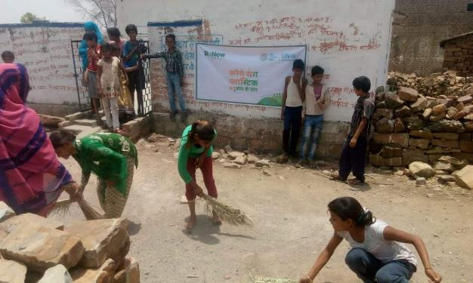

Environment Day Celebrations- A Platform for Action World Environment Day is the UN's most important day for encouraging worldwide awareness and action for the protection of our environment. Since it began in 1974, it has grown to become a global platform for public outreach that is widely celebrated in over 100 countries. The People's Day Above all, World Environment Day is the "people's day" for doing something to take care of the Earth. That "something" can be focused locally, nationally or globally; it can be a solo action or involve a crowd. Everyone is free to choose.The Theme Each World Environment Day is organized around a theme that focuses attention on a particularly pressing environmental concern. The theme for 2018 is beating plastic pollution.The Host Every World Environmen Day has a different global host country, where the official celebrations take place. The focus on the host country helps highlight the environmental challenges it faces, and supports the effort to address them. This year's host is India.
Under the program a series of school and community based activities were organized under the project which incuded painting competition organized in all school, where children were motivated to create messaging against plastic pollution. Each of these events were participated by ReNew power local members as well as school teachers and Sarpanch. This was followed by a rally of children louding slogans on plastic pollution. A unique intervention included this year was inviting a local cultural group to all the project villages to gather people and do messaging on safe environment through songs and music.

Childrens Day Celebrations: Childens day celebrations is one of the major focus of the ReNew India Initiative program. Under the Children Day Celebration program, the program converges with the local school authorities for organizing quiz and painting competions for the children in the school, followed by advocating child rights through a march though the village.

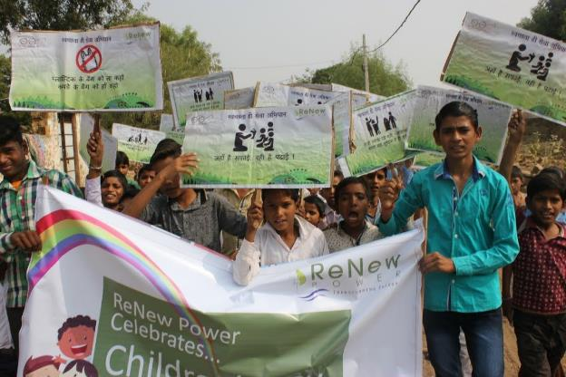

Infrastructure Upgradation- The infrastructure upgradation components of the program includes upscaling infrastructure in terms of better leanring environment for children which includes repair of school building, repair of sanitation units, and ground water recharge through roof top water harvesting structures. Ove the past three years the project has revamped the school building at Lhosghani with construction of the school boundary and repair of roof. The initial number of children attending this school was 5-10 which has now significantly risen to 20-25 children attending the school everyday. The availability of basic dire need such as water filters has ensured safe drinking water available to over 400 children in 4 school.

Edu-Hub- The edu hub being setup under the program is focused on providing digital education to children in need. Initially the center has only 10-12 children attending the center from the vijaypur towm , however with the availability of learning aids such as laptops and internet, gradually the number of children attending the edu-hub has risen to 25 children attending the center on regular basis. These essentially to mention also includes children commuting from their villages at their own cost the remedial course.

Women Empowerment- The women empowerment component of the program is focused on both women as well as adolescent girls. This includes formation of women self help groups , their capacity builing in terms of SHG operations and book keeping. This has resulted in formation of 16 groups on 4 villages, all of which have been now merged with the National Rural Livelihood Program by the government. The adolescent component of the program includes radio narrowcasting on various issues such as adolescent health and education. Recently one of the impacts of the program can be seen in terms of satellite computer classes being organized at the village level being attended by over 35 girls in all.
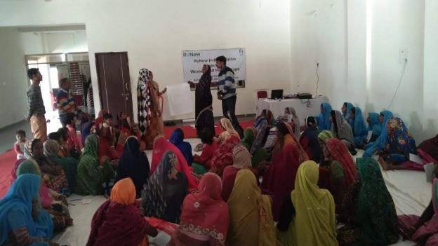
Access to Drinking Water- One of the flagship focus of the RII has been improving access to drinking water for rural communities. This has included scientific testing of the water availability, establishment of water sources and making provision for storage of this water. The other component to this has been deepening of well in ladpura, which has turned out to be a major success, making water available to about 60 families throughout the year especially when most of the water sources in the village dry up. 4 solar water motors have also been installed under the program for the Sahariya primitive tribal group in remote locations of the block , making drinking water available in underserved areas.

Health and Hygiene- The health and hygiene component of the program includes sensitization activities such as celebration of important days such as environment day, village cleaning drived, swachchta hi seva abhiyaan. This is added with school hygiene education component inculcating education of children on personal and food hygiene, handwashing at critical times and so on. A susbstantial change can be seen in terms of cleaner school compounds, cleaner classrooms, and hygiene practicing children support by teachers.

Radio Narrowcasting:
It means selecting a focused group of community members, pre-selecting an audio program and playing it to them in their village at a pre-selected location chosen and preferred by them. The narrowcast can also be used to ask community members what they would like to hear in the future, and also be used as an opportunity to record some feedback about the radio station in general or about specific programs.
Themes of Radio Narrowcasting under the program:
- Livelihood
- Health
- Child Education
- Agriculture

Noticeable Outcomes:
- Increased attendance of the students in school.
- Number of girls attending the schools has increased.
- Provision of safe drinking water at school level.
- School teachers supporting and inviting of the project activities.
- 6-All SHGs (12) looped in by National Rural Livelihood Mission and taken up by Aajeevika for RF
- Increased access of drinking water to over 800 people. The well deepening initiative has been a stellar performer, making water available for about 60 families, even in times when all other sources of water dry up.
- 51 students in total and 25 regularly attending computer education classes at the edu hub. One success criteria to this has been children willing to commute to the edu hub for attaining digital literacy, while for the girls commuting is an issue, the project is taking up satellite digital education classes at the village level itself.
- Regular intervention on SSHE (School Sanitation and Hygiene Education) depicts clear impact in terms of clean and healthy school compound, classrooms and children.
- All government flagship events well supported by the education department- Swachch Bharat Abhiyaan, Swachchta Hi Seva Abhiyaan. Teachers particpating in every activitiy and making sure children participate in all activities on days like Children Day, Environment Day, Village Cleaning Drive, Plantation etc.

Testimonials:
Through the support of Renew Power we have setup 3 water sources in our village. the most successful example of these is the one in Harijan Basti which has made water available to 40 families, which other wise would have to travel 2-3 kilomters to draw water. – Ram Niwas Rawar, Sarpanch , Hullpur

We can see change in the number of children attending the school and their cleanliness. The regular sessions and providing basic support like water filters adds to retaining students in school. With the organization of activities like drawing competition, childrens days, environment day etc , make learning more interesting for children- Radheyshyam, Headmaster, Primary School Hullpur

Though toilets were constructed in our village under the Swachch Bharat Abhiyaan, toilets were not in use, since we did not realize to see it in the light of womens safety. The regular programs being played on the radio and meetings organized for women and girls emphasizing on the need of using toilets has made sure that now no girl or women goes in the open for defecation.- Phula Bai, Dulhewala

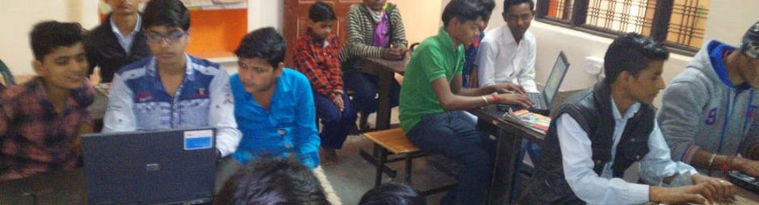

Parivartan
Sambhav has been implementing the Parivartan program in Tilori village of Malanpur, Bhind. The program is focused on educational development of the village and women empowerment through establishment of Parivartan Kendra, Upgradation of Educational infrastructure and providing supplementary education to adolescent girls in the village.
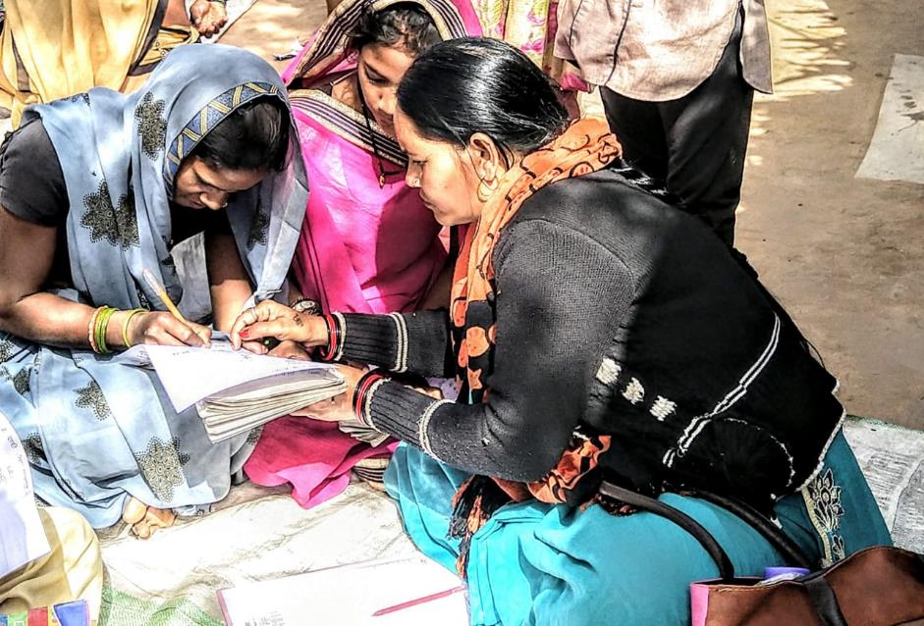
Program - Key components
Education
- Remedial Education- The remedial education component of the program works on a two way model. The first model is to provide supplementary education to children attending schools, but in need of additional support, which may not be essentially available at the village level. The second component is that of identifying dropout children from within the village and to align them with the process of education through life skill based education. The remedial education program has a dedicated centre which goes by the name of Parivartan Kendra. The centre is equipped with LCD Monitor, Power Backup, Internet, Computer Systems, Study Material and Furniture.

- Adult Education- Bhind has been infamous for its classic divide on the terms of Gender. Female infanticie, foeticide and no education to girls and women is rampant. The program includes this a prime concern and is trying to use the Adult Education module by the Government of India to educate women through its satellite centers in the Baghel, Kushwah and Sahariya basti of the village.

- Computer Education: In line with the national agenda in making India a technology friendly nation, the program works on computer literacy of girls and boys of the village. This includes various components of computer education ranging from basic software operations such as Windows, Excel, Word etc to understanding and using the internet. The center is equipped with a full time internet connection , which is regularly utilized for organizing cloud based (skype) education for children.

- Leadership and Co-Curricular Activities- Apart from the routine education regime of the program, the program envisages to develop socially aware and proactive children. A series of activities are organized at the village level for children, which include, debate competition, spelling bee, drawing competition, exposure visit etc for the overall personality development of the girl child.

- Sports Activities- In additional to the co-curricular activities , weekly and monthly sports activities are organized with almost all children attending the Parivartan Kendra and the government school. This includes games like skipping rope, kho-kho, cricket tournament and volleyball.

Social Mobilization: Regular intervention within the community and consistant interaction plays a critical role in the success of any program. From the community development perspective of the program an effort is made to involve the community by large as a primary stakeholder of the program. This essentially includes focusing on the issues that affect the daily lives of the habitants. In line with the same, a series of community based activities with special focus on education and health are organized in the community which include:
- Advocacy with the government for services
- Supporting the health machinery in the village for better health service delivery
- Observing days of special importance for greater awareness such as environment day, earth day, world water day etc.
- Promotion of household level sanitation
- Video shows on health and related issues
- Sensitization and training of women on mother and child health
- Regular health monitoring of children attending the ICDS
- Promoting health and sanitation among children
- Village cleaning drives

Infrastructure and Education Up gradation: School Infrastructure- One of the major components of the program is to make education and health infrastructure more beneficiary friendly. A series of hardware activities have been undertaken under the project to this effect. These essentially include repair of school buildings, upgrading school furniture, making provisions of electricity in school through solar power.

Inauguration of Community Center at Anganwadi:
Akzo Nobel India Limited with the support of Sambhav Social Service Organisation is implementing its flagship CSR program Project Parivartan in Tilori village of Malanpur. The major focus of the program is to work towards better education and health in the community. Several infrastructural development interventions have been undertaken under the project in the village. These interventions include reconstruction and repair of the primary school building, upgradation of the satellite School, and upgradation of the Anganwadi building in the village. The Anganwadi building and the satellite school in the village have been also provided with solar power systems to ensure better participation of the community. A community learning centre has been recently developed in one of the rooms neighbouring the Anganwadi centre. This community learning centre essentially will serve as a place where women and adolescent girls can attend the remedial education and adult education programme under the project. Since community level activities and celebrations are a major part of the project the same place will be used as the venue for various trainings, discussions and meetings. the learning centre is an extension to the Parivartan Kendra that has been set up in the village to provide computer and academic education.
An inauguration program was organized on the 22nd of August for the same where the works manager and HR manager of Akzonobel were present. Women at the community center shared their experiences of aligning with the program, followed by and introduction of the program shared by Ms.Priyanka Singh and Mr.Parthasarathi Changdhar. Ms.Sunita S Pal shared that the project is a milestone towards development in a gender bias region like Bhind, added by Mr.Kratika that the community center concept of the project is motivating.

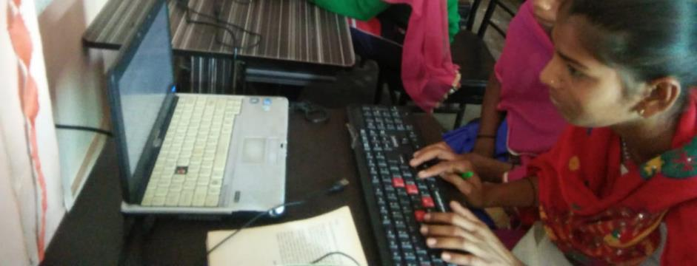
World Health Day Celebrations:
The World Health Day is a global health awareness day celebrated every year on 7 April, under the sponsorship of the World Health Organization (WHO), as well as other related organizations.
In 1948, the WHO held the First World Health Assembly. The Assembly decided to celebrate 7 April of each year, with effect from 1950, as the World Health Day. The World Health Day is held to mark WHO's founding, and is seen as an opportunity by the organization to draw worldwide attention to a subject of major importance to global health each year. The WHO organizes international, regional and local events on the Day related to a particular theme. World Health Day is acknowledged by various governments and non-governmental organizations with interests in public health issues, who also organize activities and highlight their support in media reports, such as the Global Health Council.
On this day all of our staff has helped the Village to collect a lot of Knowledge on health and Organized a lot of activities.
Earth Day Celebrations:
Earth Day is an annual event celebrated around the world on April 22 to demonstrate support for environmental protection. First celebrated in 1970, it now includes events coordinated globally by the Earth Day Network in more than 193 countries.
On Earth Day 2016, the landmark Paris Agreement was signed by the United States, China, and some 120 other countries. This signing satisfied a key requirement for the entry into force of the historic draft climate protection treaty adopted by consensus of the 195 nations present at the 2015 United Nations Climate Change Conference in Paris.
Numerous communities celebrate Earth Week, an entire week of activities focused on the environmental issues that the world faces. In 2017, the March for Science occurred on Earth Day (April 22, 2017) and was followed by the People's Climate Mobilization (April 29, 2017).
Students made Posters on Save Earth theme And prepare themselves for a theater act.
In which they have played a role. of Earth, jungle, Water, Air and Animals.All the students gave a message to save the earth.
International Women’s Day celebration
On this occasion of Women’s day we met all the women of the village. We gifted them a women’s day Bandand Made a Hug Chain. We distributed all the children specially girls Toffees and Band they were all very happy. We distributed 2000 pamphlets in which we wrote importance of women’s day. We organized a Bhajan Sandhya for the women of Village at MAA JANKI KENDRA. We organized a Meeting of Gram Samooh along with women of Village, there we communicated the basic needs of Women’s day and why we celebrate this day.
Volunteer Visit:
One of the objectives of the Parivartan program is also to involve volunteers from various backgrounds to explore the possibilities of improvement in the programs being implemented by AkzoNobel throughout the country. these visits are also an opportunity for the volunteers to learn about the methodologies of various projects and look for ways of including the best practices at a uniform level throughout the project sites of AkzoNobel in India. a three day visit was done by Mr Shivam Pal. Mr Shivam is a volunteer for AkzoNobel at the Gurgaon project. The visit of Mr Shivam started with an interaction with Nabil Singh who gave an overview of the project explaining the objectives and components of the project followed by some of the achievements and strategies of implementation. Following this Mr Shivam visited the field of the project Parivartan being implemented in Tilori village of Malanpur. This included interaction with the the girls attending the Parivartan Kendra, students of the satellite School, Anganwadi centre and and the community at large.
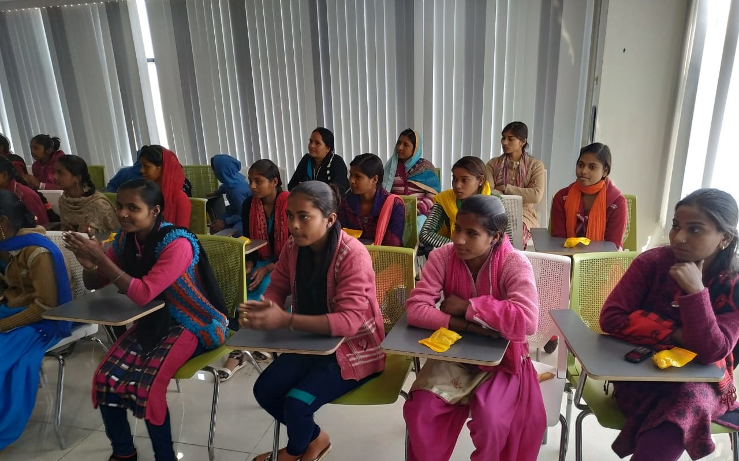

Community Needs Assessment:
In partnership with Eicher Group Foundation , Sambhav took up a service project of conducting community needs assessments in 3 Villages of Bhopal and 7 Slums of Pithampur district.
A community needs assessment identifies the strengths and resources available in the community to meet the needs of children, youth, and families. The assessment focuses on the capabilities of the community, including its citizens, agencies, and organizations. It provides a framework for developing and identifying services and solutions and building better communities.
A community assessment may be limited to a compilation of demographic data from census records, results of surveys conducted by others, and informal feedback from community partners. Or, assessments may be expanded to include focus group discussions, town meetings, interviews with stakeholders, and telephone or mailed surveys to partnership members and the community.
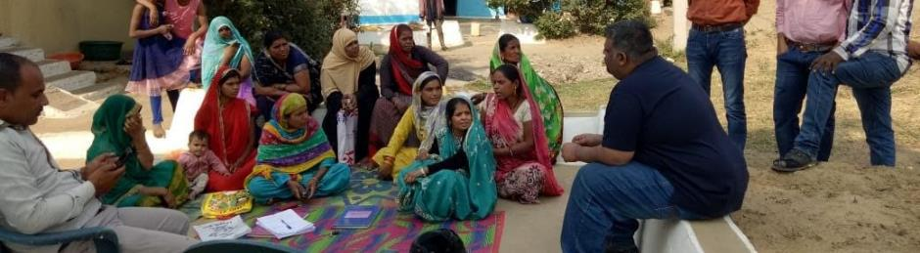
Step 1: Transect Walk:
A transect walk is a systematic walk along a defined path (transect) across the community/project area together with the local people to explore the slum conditions by observing, asking, listening, looking and producing a transect diagram. The transect walk is normally conducted during the initial phase of the fieldwork. It is best to walk a route, which will cover the greatest diversity in terms of resources and infrastructure. The transect walk is conducted by the research team and community members. The information collected during the walk is used to draw a diagram or map based on which discussions are held amongst the participants.
Step 2: Social Mapping:
After the transect walk has finished, sit down in a suitable place with the local community to discuss and record the information and data collected. Prepare an illustrative diagram of the transect walk using the information. The diagrams can be prepared on a large sheet of paper (or on the ground). On the top line, illustrate the different zones that the local analysts visited. Down the side, list headings of the areas of interest (plants, land use, problems, drainage system, and so on) and then fill in the details of what was observed in each zone.
Step 3: Focus Group Discussions:
A qualitative method of needs assessment. A group interview that explicitly uses group interaction as part of the method to generate data, i.e. people are encouraged to talk to each other and ask questions, exchange anecdotes and comment on each others' experiences and points of view. A focus group discussion involves gathering people from similar backgrounds or experiences together to discuss a specific topic of interest. It is a form of qualitative research where questions are asked about their perceptions attitudes, beliefs, opinion or ideas. In focus group discussion participants are free to talk with other group members; unlike other research methods it encourages discussions with other participants. It generally involves group interviewing in which a small group of usually 8 to 12 people. It is led by a moderator (interviewer) in a loosely structured discussion of various topics of interest. In focus groups a group of between 4 and 12 participants are led under controlled conditions to discuss a specific topic. The objective is to identify opinions, experiences and attitudes of participants and the group as a whole, and to observe behavior patterns and group dynamics. The advantages lie in the low-cost and relatively quick, simultaneous surveying of several people, and insight arising from group effects that might not emerge in individual interviews.
Step 4: Base Line Survey:
A baseline study simply put is a study that is done at the beginning of a project to establish the current status of a population before a project is rolled out. Just like the name suggests, baseline surveys should be carried out at the very beginning of a project and for obvious reasons. Any implementer wants to ensure that any possible impact of a project is captured at the evaluation. Where a baseline study is conducted after project activities have already been initiated, the accurate picture of the initial status cannot be reflected since the project is already having some impact, however little. It is therefore always best practice to conduct a baseline before project implementation.
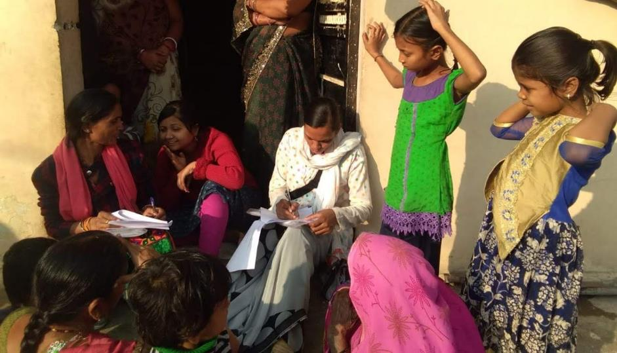
Frame of Questions:
- Respondents basic information
- Economic status
- Educational status
- Aspirations in terms of Education, Livelihood, Skills etc

E- Community- Educated, Empowered, Enabled, Expressive

Pithampur is one of the largest Growth Centers in Central India and a well-developed industrial town of Madhya Pradesh. Located at 30 kms from the city of Indore, the Growth Centre is spread across an area of nearly 2000 hectares. With about 122 medium and large-scale industrial units, and more than 455 small-scale industries, Pithampur has attracted cumulative investment of over Rs. 68,250 million and today provides employment to approximately 25,000 people. The automotive industry is one of the most significant constituents of the Growth Centre.

The project is based on the findings of the Community Needs Assessment done by Eicher Group Foundation, focused on 7 thematic areas i.e. Health, Education, Livelihood, Women Empowerment, Skill Development, Environment and Government Policies. The ideation of the project is based on three priority areas derived from the findings of the Community Needs Assessment namely:
- Health
- Education
- Women Empowerment

Launch Program: 20th June 2019
The launch program of SIIDC (Sustainable Initiatives for Integrated Development of Communities Project) was organized here at Hotel Dhakad Empire, Pithampur in the presence of Mr.Lalit Joshi, GM VE Commercial Vehicles and Mr.Milind Bugde, DGM-IR, VE Commercial Vehicles Limited. The program was jointly facilitated by Mr. Tanveer Javedi (EGF) and Nabil Singh ( Sambhav). The program started with a round of introduction of all the delegates. After the introduction the program initiated with Mr. Tanveer Javedi giving an overview of the vision to SIIDC program, followed by an in-depth presentation on the SIIDC Program by Nabil Singh. BEO Nalcha Mr.Jadhav applauded the initiative and extended all possible support to the program. This was seconded by Ms.Kalpana Bhargava, Principle, Govt Girls School, Mr.Asif Khan, Manager, Narmada Jhabua Grameen Bank and Ms. Bhaskar (Livelihood) from Municipality, Pithampur.
Mr.Milind Bugde shared the importance of community participation in such programs. Moreover, Mr.Lalit Joshi shared in an interactive way of how community participation is the key to the success of the SIIDC Program. This was followed by a cultural program (puppet show) that capacitated the essence of the program. The program witnessed an attendance of 109 people. The vote of thanks was delivered by Ms.Sheetal.

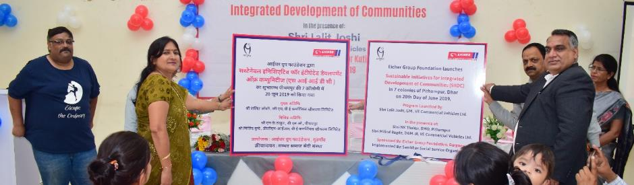
Staff Training Program: MIS & Reporting
The first training of staff on MIS and Reporting was undertaken by Ms.Priyanka Singh on 16th June 2019. The training program was attended by all the staff members of the project. During the training program Mr. Nabil expressed the need of very strong MIS System within the project as to facilitate the reporting and monitoring of the project.

The following components of MIS and Reporting were discussed during the training program:
- Center level data – Students- Attendance and Progress
- SHG level data
- Slum Level Data: Events, Meeting etc
- Component level data
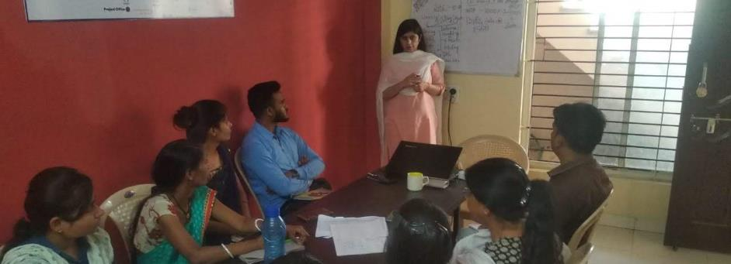

Trainings of Adolescent Girls on Menstrual Hygiene and Gender:
Three training programs were organized for Adolescent Girls on the concept of Mentrual Hygiene and its connection with the overall physical and mental development of a Girl Child. Menstruation is still a taboo in India and it is common for people across society to feel uncomfortable about the subject. To ensure that adolescent girls and women have the necessary support and facilities, it is important that the wider society, communities and families must challenge the status quo and break the silence around menstruation.
The training programs began with an orientation of the girls on understanding the entire concept of Gender and the relevance of gender equality in the fast moving world today. This included use of powerpoint presentations , flip charts as well as videos. The session was followed by a session on the common myths in respect to gender exercised in the community, and how the same can be challenged through proper orientation and knowledge. Number of participants- 179.
The menstrual hygiene session of the training program included:
- Understanding menstrual hygiene and its phases
- Management during menstruation.
- Common problems and home based remedies.
- Emphasis on use of sanitary napkins
- Correlation of menstrual hygiene with mental , physical and psychological growth of a girl child.
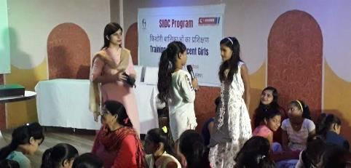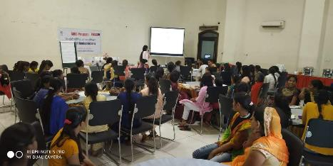
Training of Women Self Help Groups on Book-Keeping- 43 Women Trained
One of the major pillar objective of the E Community program is to look for ways of financial inclusion and creation of a safety net for the women in times of despair. To overcome the same one of the proposed strategy under the program is formation of women self help groups and train them on the basic elements of SHG concept and book keeping, alongwith rules and regulations to be followed by a SHG. The following of rules and regulations will enable the SHG have a better grading from financial institution and outreach to credit support for upscaling existing income avenues. As a part of the 3 trainings organized under the program for the 3 SHGs formed under the project., the following components were taken up by SHG Expert Mr. Halim Khan:
- Concept of SHG
- Rules and regulation of SHGs
- Basic book keeping
- Cash Management
- Daily income and expense monitoring
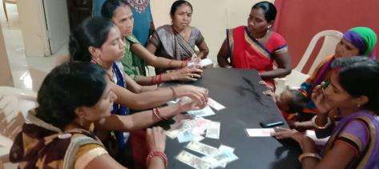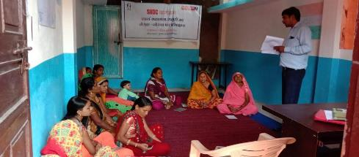
Training of Women on Women and Child Health
New born care along with proper management of pregnancy and care of mother plays a critical role in the mental and physical growth of child and mother. More importantly this plays a rather special emphasis on addressing common problems of malnutrition, anemia and high-risk pregnancy. It is with this in center as an objective that 3 training of women from 3 slums were organized under the program in the reported quarter. The training has Dr.S.K.Singh, Dr. Durgesh Prasad and Dipika as the resource persons. Number of women trained- 94. The training module included:
- Understanding pregnancy and possible complications.
- Balanced diet of child and mother.
- Importance of exclusive breastfeeding.
- Necessity of menstrual and personal hygiene during preganancy.
- Management of malnutrition in children and anemia and mothers.
- Consumption of IFA tablets, complete ANC /PNC
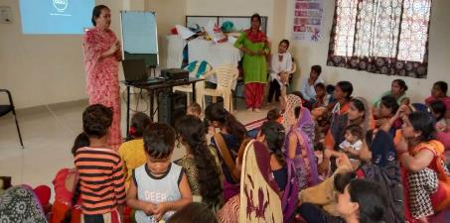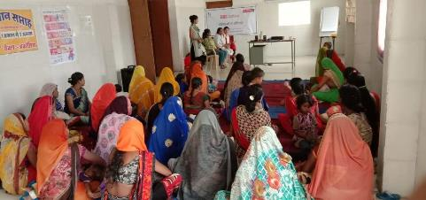
Community level IEC Activities:
Behavioral change within the community is directly related to the way messages are transmitted and disseminated in a community. IEC play an crucial role in ensuring that the project messages around women empowerment , sanitation, and education. For this purpose the project has undertaken a series of IEC activities to ensure that the community is kept involved as a primary stakeholder of the project. Following activities were undertaken in the quarter in terms of IEC :
- Celebration of Environment Day
- Celebration of Independence Day
- Organizing two Sanitation Awareness Rally- 2
- Organizing Nukkad Naatak- 7
- Collaterals for slum entry boards designed and under process placement.
- Awareness sessions for women and Girls- 24

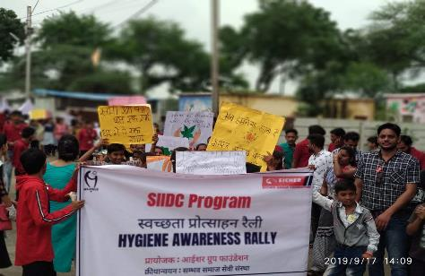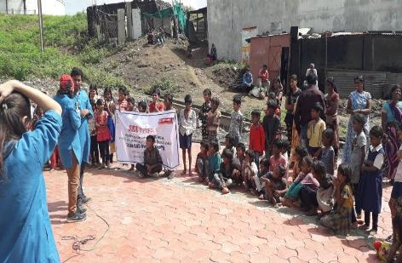
Training of Teachers on Remedial Education:
A training was organized for all the teachers of the Remedial Center at the Project Office on 22nd July. This training was also attended by representatives of EGF. The training included on working with the remedial teachers on how do they understand remedial education and how the remedial education program can be made more useful for the children in the community. The training program included orientation on understading the various dimension of remedial education , role of a remedial educator, preparing curriculums, finalization of SOP for all remedial centers, performance tracking of students, children in special need and so on.
Remedial Education:
The remedial education component of the program works on a two way model. The first model is to provide supplementary education to children attending schools, but in need of additional support, which may not be essentially available at the village level. The second component is that of identifying dropout children from within the village and to align them with the process of education through life skill based education. The remedial education program has a dedicated centre which goes by the name of Community Learning Center. The centre is equipped with Computer Systems, Study Material and Furniture.

Computer Education: In line with the national agenda in making India a technology friendly nation, the program works on computer literacy of girls and boys of the village. This includes various components of computer education ranging from basic software operations such as Windows, Excel, Word etc to understanding and using the internet. A module has been created to this effect.

Leadership and Co-Curricular Activities- Apart from the routine education regime of the program, the program envisages to develop socially aware and proactive children. A series of activities are organized at the center level for children, which include, debate competition, spelling bee, drawing competition, for the overall personality development of the girl child.

Sabla- Program on Violence Against Women

Violence against women can be defined as physical, mental, economic and psychological, at both places inside and outside of the house. After the Nirbhaya Case in New Delhi, Government of India has prepared new guidelines and a new law is in place named Domestic Violence Act. Some of the main characteristics of this act are:
- Creation of women helpline 1090/1091, where all the complains of violence against women can be reported.
- Creation of a one stop crisis center , where the state is planning to provide multiple support to the victim i.e. DIR (Domestic Incidence Report), Medical, Legal , and Short Stay Home.
- Mahila Thana (Women's Police Station ) has been created, where 24 hour women complains are received and police is sent for help.
- Counseling Centers: There are counseling centers , now at mahila thana and SP office, and a mediation center , where women can seek remedial support.
- Jan Sunwai (Public Hearing) taking place at police, district magistrate and the municipal corporation to address the issues starting from violence against women to the malfunctioning of services, corruption and lack of support from the institutions.
In addition to this Chief Minister Helpline, filing complaints through letters and emails are also in place.
The organization has come to an understanding, that all women, men and girls be made of above support system. The organization also helps in actually interfacing with the services for a practical and real experience. In case of poor response , from these service providers, they should also know to take help of media , National Commission for Women and MLA's/MP's to build advocacy pressure on the services for quick response.

- Training of Women , Adolescent Girls and Male youth on the issues of:
  - Gender Equality
  - Cause and forms of violence
  - Avenues for support
  - Developing a consensus on how to address VAW.
2- Interface: Organizing community level meetings in each slum involving community institution members (SHG, Adolescent girls, paralegals, other collectives) with the selected service providers on VAW such as Police, persons involved in community policing, protection Officers, Aanganwadi workers, Health Service provider, financial institutions etc.
3- Thematic sessions with women and adolescent girls to further discuss each component of violence against women in depth. Objective is to create an open space where women can raise issues and understand along with peer learning:
- Session 1: Violence against women is a result of inequality.
- Session 2: Laws to address violence against women.
- Session 3: Criminal justice system
- Session 4: Rights in Marriage
- Session 5: Child Marriage
- Session 6: Safety Planning and Action
4- Referral: Referring identified cases of violence to:
- District Legal Services Authority
- Mahila Thana
- Protection Officer
- One Stop Crisis Center
- Ward Office
- Jan Mitra Kendra
- Various Help lines
Testimonial from Jana Urban Foundation:
The project witnessed scale and magnitude over the years in terms of addressing the pressing issue of violence against women in 40 slum areas of Gwalior, Madhya Pradesh. You have effectively managed to create some tangible outputs during a short span of time for an issue that faces a great amount of resistance on the field. Some of these outputs are the establishment of a legal centre which aims to provide legal and counselling support to the victims of violence. As of today, over 800 cases have been identified out of which 400 have been addressed in the form of legal action, entitlement and services. 62 women have been trained and registered as para-legal workers to form the Mahila Adhikar Panchayat, a consortium of women responsible for voicing the concerns of the women to urban local bodies and other service providers. Through regular interface meetings, issues of garbage disposal, community toilets, drinking water and street lighting have been initiated and acted upon. Cases of violence and harassment are regularly being reported by the women and adolescent girls through widespread information on avenues such as police, women and child helplines and mahila thanas. 270 youth and men of the community are also being sensitized through the project. It has indeed been a very meaningful and fruitful partnership with your organization.

Self Help Promotion
To promote and facilitate credit linkage of Self Help Groups (SHGs) with banks and provide continuous handholding support. The programme is an attempt that through Self Help Promoting Institutes (SHPI) to work for promoting and enabling credit linkage of these group
s and also ensure loan repayment.
Our Self Help Group-Bank Linkage Programme (SBLP) in partnership with ICICI bank aims to deliver financial products & services to the section of Indian population that lacks access to formal banking. This segment, often from the lower income, meets its financial needs through informal sources such as money lenders, traders, family and friends etc. However, these sources have their own limitations.
The SHGs are also encouraged to take up livelihood activities. The members of the SHG are encouraged to save and internally lend the savings to members during times of need. SHPIs also provide knowledge on managing books of accounts.
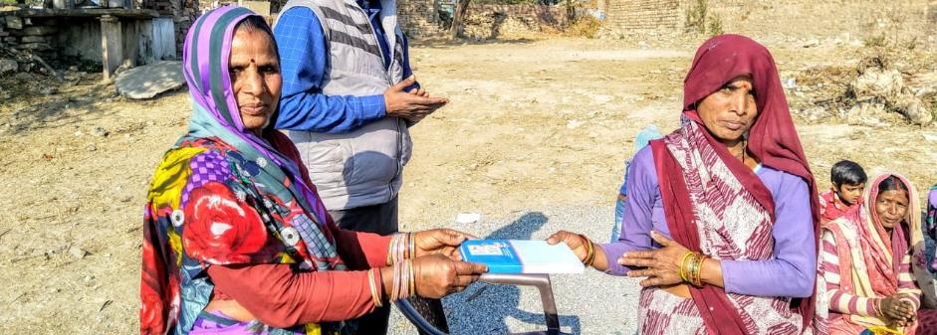
- Number of SHGs Formed: 110
- Total Loan Disbursed: 7100000/-

Shri Padam Sambhav Eye Hospital
The hospital being run by the organization in Shivpuri district of Madhya Pradesh, saw some coming in from other institutions in the region. The first support came in from Ratan Jyoti Netralaya, Gwalior, that partnered with the organization for organizing screening camps and performing free caratact surgeries for over 100 patients and the same number of paid surgeries. The hospital building has been also put into use of walking in patients for OPD with the support of local doctors in Shivpuri.
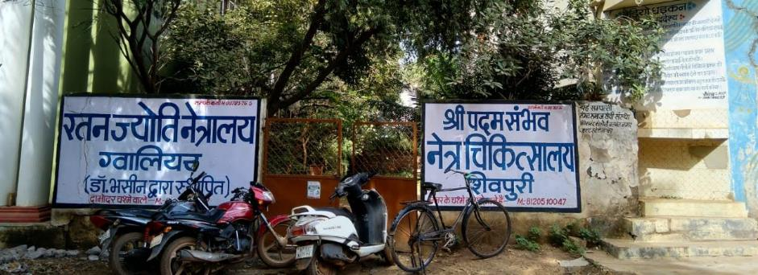

Radio Dhadkan: Bridging the Digital Divide
Sambhav in support of Development Alternatives initiated a project on “Bridging the Digital Divide”.As community based organisations (CBOs) work closely with communities, they play a critical role in understanding and addressing their issues and challenges. The initiative undertaken was to work with CBOs who in turn were supposed to connect communities to expert advice for addressing livelihood concerns and facilitate processes of livelihood linkages. These were the CBOs who were anchoring the community radios so that the gap between people’s information level and existing livelihood options, govt. schemes and programmes can be sustainably reduced.
This project has two components: Technology and Livelihood. Under livelihood component of the project, CBOs (having community radios) worked towards developing and disseminating content on livelihood opportunities. The initiative also facilitated livelihood linkages and provided awareness on livelihood solutions and income generation opportunities.
Radio Dhadkan covers a population of over 130,000 (in 21 villages and urban parts of Shivpuri). Based on community consultation, programmes are created on a number of issues, including employment, water and electricity, education, early marriage, alcoholism, sexism, and corruption. s. During narrowcasting, radio programmes are played on a portable tape player and feedback regarding programmes is elicited from listener groups; based on this feedback, programmes are modified for broadcast. An integral part of this process is the contribution of experience, knowledge, and folk music from the community.
Trust Your Talent and be Attentive to Opportunities
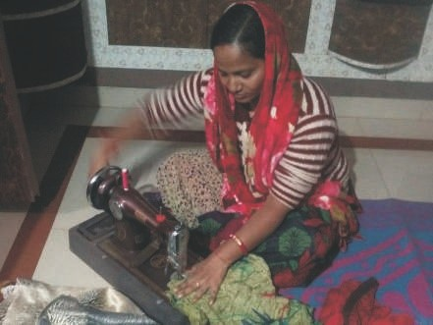
36-year-old Sandhya Sharma is a resident of Gandhi Colony in Madhya Pradesh’s Shivpuri district. Educated till class 8, Sandhya belongs to a family that is struggling hard to make their ends meet. At present, her husband sell eggs and chicken to earn a living. However, the money they earn is not enough to sustain their family. The financial crunch led to several problems in their house – taking loan at huge interest rate, frequent fights, all this was affecting the upbringing and education of her younger brother and sisters in the house.
“One day, a well-informed sister visited our colony and made us listen to the radio programme - Aajeevika that was informing the listeners on the topic of sewing and tailoring. I heard the complete session and decided to get training from an appropriate place,” shared Sandhya. Within two months, Sandhya learnt the skill of stitching, and simple basic techniques of running a house based income generation activity. Then she started her own business from her house. In the beginning, the profit wasn’t much and arranging for raw material was also bit of a task. But with Sandhya’s sheer dedication and hard work, her work started gaining recognition in the area. Today, she earns Rupees 5,000-6,000 every month which is enough to take care of the children.
Sandhya has deep appreciation about the Aajeevika programme and the agencies who are involved in the making and dissemination of this livelihood programme as this has changed her way of thinking and has helped in resolving the dire problem of earning livelihood, without moving out of her house.
Age is Not a Bar for Any New Initiative

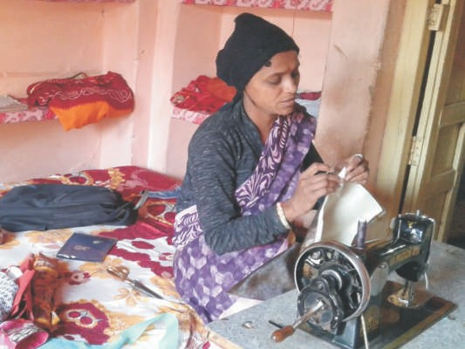
42-year-old Aabida Khan resides in the Imam Bada colony in old Shivpuri area of Shivpuri district in Uttar Pradesh. Aabida, who was involved in some work or the other her entire life, is unemployed in this phase of her life. Her two sons earn by repairing watches. But currently their work isn’t helping them earn money as many people have stopped wearing watches and have started relying on mobiles for knowing the time. This has left the entire family financially unstable.

Aabida was unhappy about this situation and was constantly worried to do something which would ensure her a stable source of income. One day Aabida, over Radio Dhadkan heard the Aajeevika programme where listeners were informed about benefits of forming Self-Help Groups (SHGs). She was happy to understand as how having part of a SHG could help not only save money but to take bank loan to start small businesses.

This inspired Aabida, and she contacted the Radio team who has made this programme. After receiving all the necessary information from the show, she conducted a meeting with the women of her area to discuss the concept of SHGs. In the beginning, many women rejected the idea but after some persuasion Aabida managed to form a SHG with 10-12 women.

She went to the bank and registered her group as Ambedkar Self-Help Group and the group members started saving money. After 6 months, the group was able to get a loan from the bank. This motivated the group. They all started the crafts work. The hand-made products of the group are now displayed and sold at different exhibitions across the districts.

“At present, each women member of the group is earning approximately Rupees 4,000 which will hopefully increase in future. I feel lucky to receive such an important information from Radio Dhadkan,” said Aabida while expressing her gratitude to Radio Dhadkan, their team, the people who are behind this concept and the organisers of such good livelihood programme for showing her the right path of self-dependency and prosperity.

Right Information with Talent, Dedication and Patience - Key to Success

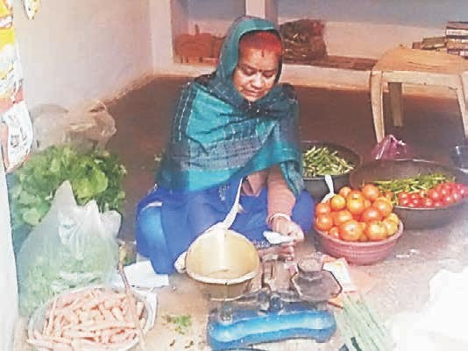
A resident of Thakurpura Road in Shivpuri, 45-year-old Sheela Jatav lives in a family of seven. Her husband and son worked as daily wage labourers and were well exposed to the uncertainty of this field where getting work every day was a huge challenge. Rest of the family members included three daughters and one daughter-in-law who had nothing to do other than the daily household chores. The entire family was facing a financial crunch that led to frequent quarrels between the family members. Helpless, Sheela stayed patient all this while. But gradually, things had started getting worse, as with inflation meeting of day to day expenses was becoming very difficult.

Sheela was constantly struggling to find a way out as she wanted to make things better for her family. One day, while listening to the Aajeevika programme on Radio Dhadkan, she finally found her way. The show shared how skills, dedication and patience are the only key for people to successfully start a work of their own. If one doesn’t have space, even then they can start selling vegetables using a push cart.

This inspired Sheela to a great extent and she started her business of selling vegetables the very next day. She bought vegetable worth Rupees 200 from the vegetable market and sold it from her house. She started making profit from the first day itself. This encouraged her to continue working hard. Currently, she buys vegetable worth rupees 2,000 and earns a profit of Rupees
400 every day. This gives her a monthly income of Rupees 10,000 -12,000.

She expresses her feeling by saying “I am grateful to Radio Dhadkan and the organisers of this programme. It is because of them I could start a new life, and change the story of increasing problems in the family towards better and secured future”. She further mentioned that in utter darkness a ray of hope is much needed and this Aajeevika programme has served as a ray of hope for her and the entire family.

New Skills, New Hopes and New Life

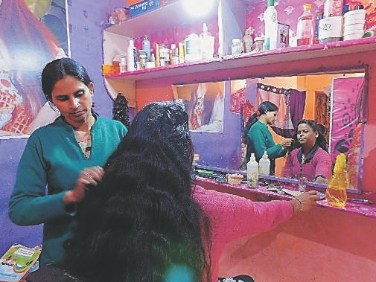
25-year-old Sinku Kushwaha lives in Siddheshwar colony, Shivpuri. A divorcee, Sinku lives with her daughter and two brothers. Her life with her husband wasn’t peaceful as they used to have frequent fights. This led to their divorce. Sinku moved in with her brothers hoping to have a relatively comfortable life but soon after, the health of her brothers deteriorated. This put responsibility of the entire household on Sinku who would work day and night to earn money but wasn’t able to sustain the family.

One day, while Sinku was at home, some people who were visiting her locality, played Aajeevika programme on radio Dhadkan. The programme was motivating and encouraging people to believe in themselves as it required only self-belief and dedication to start a business. Sinku heard how one can earn money by establishing their own beauty parlour. “I was already aware of the basics of the work. Besides, I took one-month training to learn it professionally. After my training I started my beauty parlour from home,” shared Sinku who initially bought only a handful of equipment as she was sceptical.

However, gradually, her business started to grow. Today, she has no time to keep thinking and worrying. During wedding seasons, she has to cater to the demands of her customers at night as well. Now everyone in the nearby locality knows her – about her good skills and the hard work. “Now, people have started hiring me for doing bridal make-up as well for which I charge Rupees 2,000. This has not only helped me to take care of my brothers but to provide my daughter decent education. I am grateful to Radio Dhadkan and the organisers of the programme (who brought this concept to action) for making me aware of the new opportunities that helped transform my life,” shared Sinku with a smile on her face.

Radio – A Real Source of Motivation

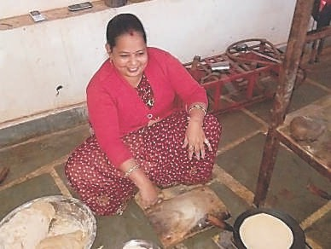
Originally from the city of Kanpur, Deepali Gupta post her marriage had shifted to Subash Colony in District Shivpuri. She belongs to a lower middle class family. Her husband was an auto driver but due to some circumstances he stopped driving auto. She has two children - elder one goes to a government school while the younger one stays at home. Deepali, being a new age woman, was well aware of the financial condition of the family and knew that once the younger child will start going to school, it would be difficult to maintain the household expenses. She would keep thinking of alternatives and was looking for that one chance to prove herself. Her husband shared her concern.

In January 2018, a team from Radio Dhadkan visited the area and discussed a programme (Aajeevika) on livelihood. Deepali heard the programme with great interest and concentration. After the programme was over, she decided to work as a domestic help while her husband started selling bread in the region.
In the beginning, she got hired in just 1-2 houses while husband struggled in making profit by selling bread. But the kind of determination they had, things were meant to change. Gradually, people got to know about their work and there was a sudden increase in their earnings.

Now Deepali works as a cook in 2 houses and earns a very good reputation besides earning decent income while her husband has started selling biscuits along with bread. Together, they are making Rupees 5,000 a month. At present, he has to visit houses to sell biscuits and bread but soon they plan to start selling it from their house itself as many people come there to collect bread.

Once this will work out, she also plans to get involved in this bread-biscuit business. Deepali says that currently she is earning Rupees 3,000 and hopes that with hard work and dedication, the amount will increase soon. She is quite happy today and credits whatever little she has achieved to Radio Dhadkan station team and the organisers of this very good livelihood programme, who visited their village and provided her the encouragement and right direction.

SAMBHAV SOCIAL SERVICE ORGANISATION

BALANCE SHEET AS AT 31ST MARCH 2019
SOURCES OF FUNDS | Schedule | ` | `
Corpus Fund |  |  | 4263867
Other Funds | 1 |  | 20676523
Loan from Banks/FIs under Micro Finance Scheme | 2 |  | 15266680
Other Liabilities |  |  | 2717230
Income & Expenditure Account |  |  | 967,876
Total ` |  |  | 43892176
APPLICATION OF FUNDS :
Fixed Assets | 3 |  | 20037325
Investments | 4 |  | 4346
Current Assets, Loans & Advances
Grant Receivable | 5 | 1719539
Cash Imprest with staff |  | 82016
Loans to SHGs and others |  | 20700661
Advances |  | 288076
 |  | 22790292
Balance with Scheduled Bank
On Saving Bank Accounts |  | 861645
On Fixed Deposit Accounts |  | 198568 | 23850505
Significant Accounting Policies and | 10
Notes on Accounts
Total ` |  |  | 43892176
As per our Separate Report Attached.
FOR GUPTA NAVIN K. & CO., For SAMBHAV SOCIAL SERVICE ORGANISATION
Firm Registration Number: 006263C
CHARTERED ACCOUNTANTS
NK Gupta | S. K. SINGH NEELAM KULSHRESTHA
PARTNER | SECRETARY |  | TREASURER
Membership No: 075030

SAMBHAV SOCIAL SERVICE ORGANISATION
INCOME & EXPENDITURE ACCOUNT FOR THE YEAR ENDED 31ST MARCH 2019
 | INCOME | Schedule | ` | ` | `
1 | Voluntary Contribution / Grants | 5
 | Specific Projects
 | Grant Received during the year
 | In cash |  | 4830824
 |  |  |  | 4830824
 | Less: Receivable Amount as on 01.04.2018 |  |  | 848582
 | Add: Receivable Amount as on 31.03.2019 |  |  | 1719539 | 5701781
2 | Interest from Bank |  |  |  | 57938
3 | Donation & Voluntary Contribution and Misc. Receipts |  |  |  | 2354097
 |  |  |  |  | 8113816
 | EXPENDITURE
1 | Salaries & Other Benefits | 6 |  | 2096506
2 | Programme & Activities | 7 |  | 4969524
3 | Administration Expenses | 8 |  | 911671 | 7977701
 | Excess of Income over Expenditure |  |  |  | 136115
 | Less: Transfer to Fixed Assets Fund
 | - Specific Project | 9 |  | 35751 | 35751
 | Excess of Income over Expenditure |  |  |  | 100364
 | Income/ (Expenditure) Account
 | Brought forward from Previous Year |  |  |  | 867512
 | Excess of Income Over Expenditure
 | carried over to Balance Sheet |  |  |  | 967876
 | Significant Accounting Policies
 | and notes on Accounts | 10
As per our separate report attached
FOR GUPTA NAVIN K. & CO., For SAMBHAV SOCIAL SERVICE ORGANISATION
Firm Registration Number: 006263C
CHARTERED ACCOUNTANTS
NK Gupta |  | S. K. SINGH NEELAM KULSHRESTHA
PARTNER |  | SECRETARY |  | TREASURER
Membership No: 075030

SAMBHAV SOCIAL SERVICE ORGANISATION, GWALIOR
SCHEDULE "3" ANNEXED TO AND FORMING PART OF THE BALANCE SHEET
AS AT 31ST MARCH 2019
S.NO. | PARTICULARS | BALANCE | ADDITION | DISCARDED/ TRFD . DURING THE YEAR | TOTAL
 |  | AS AT | DURING |  | AS AT 31ST
 |  | 01/04/2018 | THE YEAR |  | 03/31/2019
1 | Land | 3,742,337 | - | - | 3,742,337
2 | Building | 4,204,427 | - |  | 4,204,427
3 | Furniture & Fixtures | 803,575 | 25,371 | 90,847 | 738,099
4 | Computer & Printers | 1,680,555 | - | 105,000 | 1,575,555
5 | Electrical Equipments | 727,429 | 10,380 | 7,800 | 730,009
6 | Office Equipments | 439,921 | - | 14,420 | 425,501
7 | Vehicles | 3,018,704 | - | - | 3,018,704
8 | Jetpump/Submersible Pumps | 16,869 | - | - | 16,869
9 | Borewell | 65,672 | - | - | 65,672
10 | Radio Station Equipments | 1,760,307 | - | - | 1,760,307
11 | Hospital Equipments | 3,625,079 | - | - | 3,625,079
12 | Projector | 134,766 | - | - | 134,766
 | Grand Total (Rs.) | 20,219,641 | 35,751 | 218,067 | 20,037,325
SCHEDULE : 4
INVESTMENTS
Investment in UTI Mutual Fund
(1.144 units, NAV Rs.3511.3637 per unit ) |  |  |  | 4,346
Total ` |  |  |  | 4,346

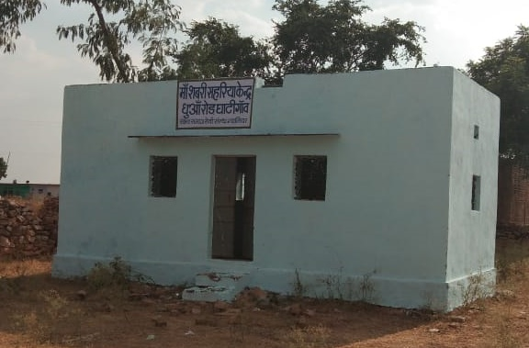  Figure 1: Ghantigaon, Gwalior | 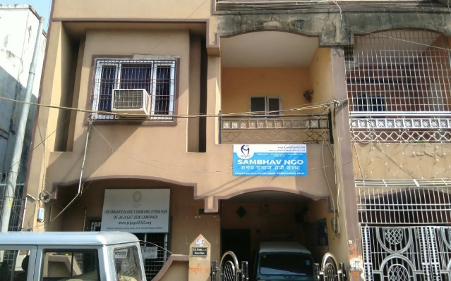  Figure 2: Head Office , Gwalior
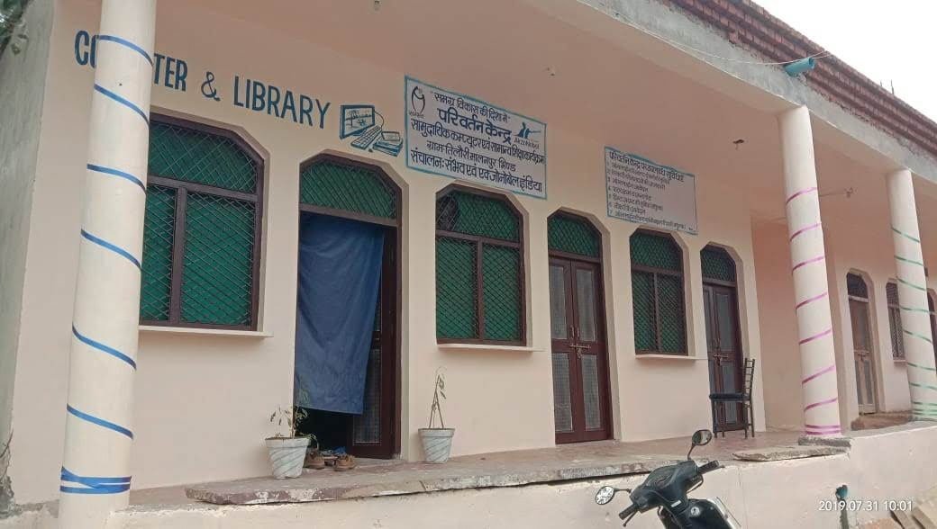  Figure 3: Computer Center and Library, Tilori | 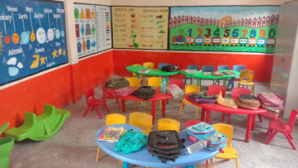  Figure 4: Remedial Center, Sahariya Basti, Tilori
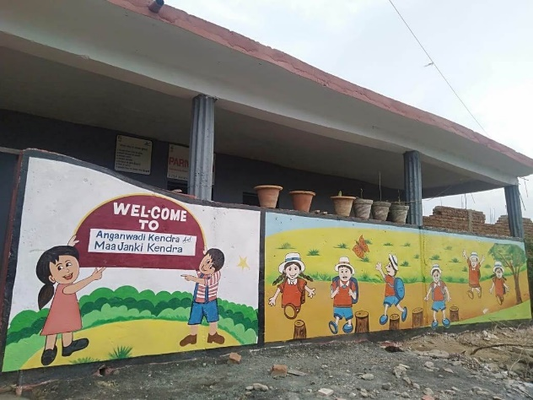  Figure 5: Maa Janki Kendra, Tilori | 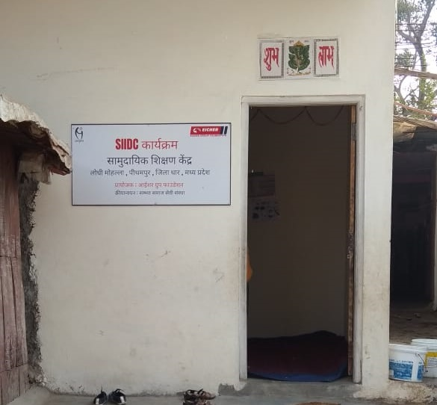  Figure 6: Education Center, Lodhi Mohalla, Pithampur
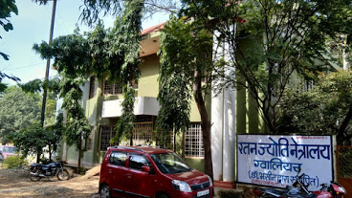  Figure 7: Eye Care Center, Shivpuri | 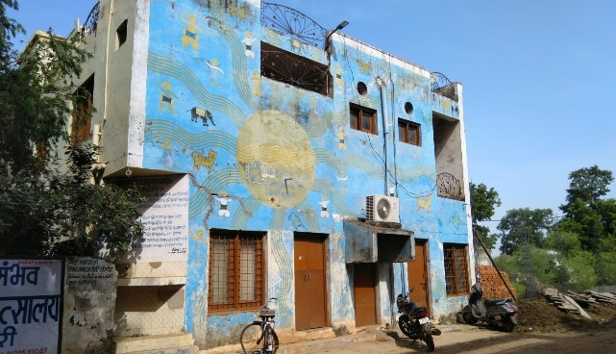  Figure 8: Community Radio , Shivpuri
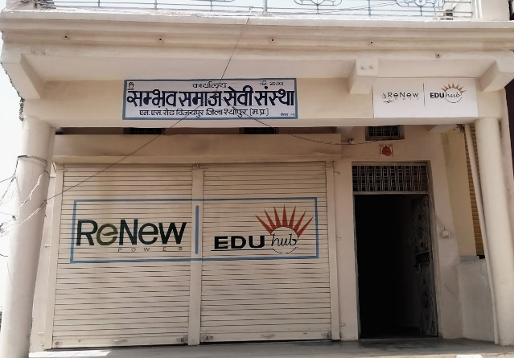  Figure 9: Education Center, Vijaypur Sheopur | 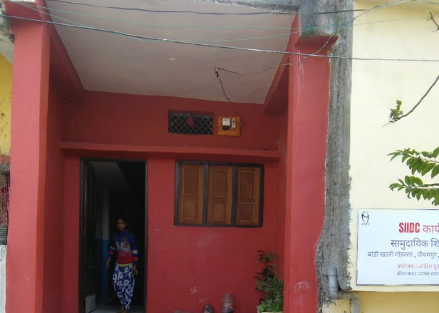  Figure 10: Education Center, Baandhi Khali, Pithampur
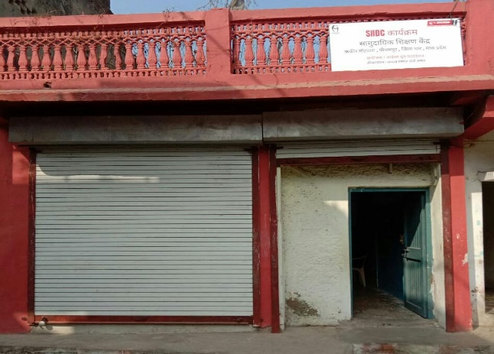  Figure 11: Education Center, Fakir Mohalla, Pithampur | 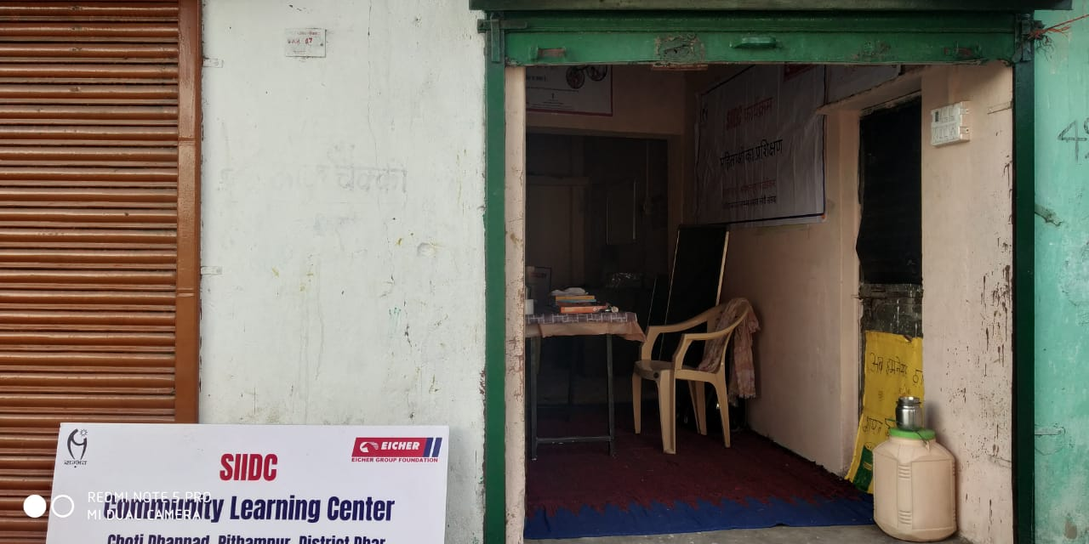  Figure 12: Education Center, Choti Dhannad, Pithampur
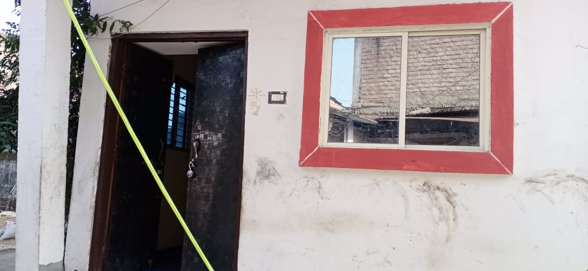  Figure 13: Education Center, Harijan Mohalla, Pithampur | 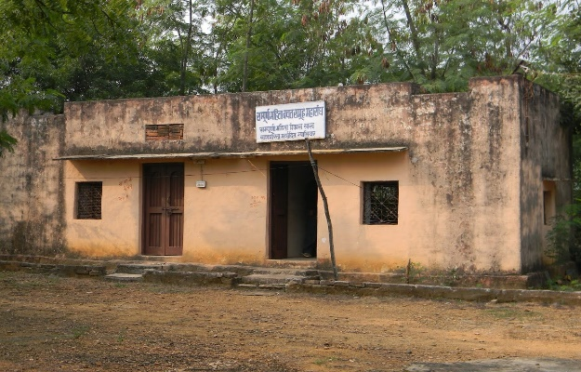  Figure 14: Mukta Training Center, Raipur Khurd, Gwalior
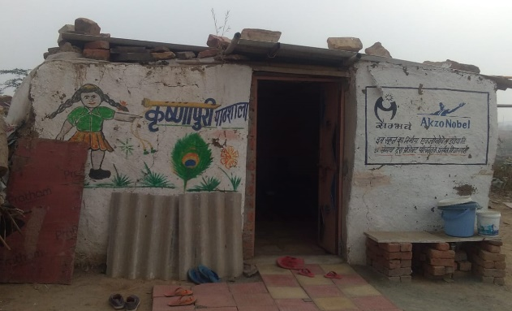  Figure 15: : Education Center, Krishnapuri, Malanpur | 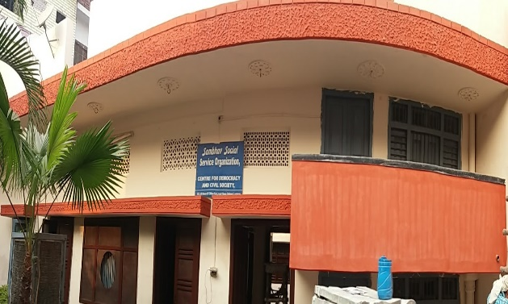  Figure 16: Lucknow Office

